Individual Report
Visual Simulation
ST20197697
VAR6001

Table of Contents
Introduction 3
Background & Research 3
Implementation 3
Evaluation 5
What went well? 5
What didn’t go well? 6
What could be Improved? 6
Wider Game Project 6
Conclusion 6
References 7

Introduction
This report will outline the subsystems that were implemented into the main game. Some of the subsystems that will be discussed in this report are car spawning, despawning and gaining points. the visualisation of the game is to show the number of cars each set country has be capita (Hedges Company, n.d.). The design of the game was based on the game Crossy Roads where the aim of the game is to get your character to jump through as many lanes of traffic and rivers without dying to achieve a high score (Hipster Whale, 2014-2020). This game could be used in many ways such as an educational game showing the vehicle per capita per country, or the game could be used as an educational game about crossing the road as the main objective of the game is to not get hit by a car.

Background & Research
Data visualization is a representation of information by showing the user visual components such as charts, graphs, maps or interactive pieces such as games or user-driven data analysis, One of the benefits of data visualization is that it can be a more engaging way to get users to process data as well as making the data easier to understand, another benefit of visualization is that it combines both art and colours with data to make it simpler to understand and not as boring (tableau, n.d.). there are many different types of data visualization which can vary from easier-to-understand ones such are a bar graph to more complicated ones such as radial tree (tableau, n.d.).
Data visualization can be used in many different ways in video games such as a basic health bar in a first-person shooter to a complex technology tree in a Strategy game or an inventory and HUD system in a sandbox game, other ways games use data visualization could be to show the player their kill: death ratio (Hazzard, 2015).
One study on game visualization found that after looking into many different game genres and the types of visualization that they use the visualization is still in early development and that gaming still has a long way to go when it comes to data visualization, this is because that most of the different games genres have many different requirement when it comes to visualizing data which makes it very difficult to get precise data over to the user (Zammitto, 2008).

Implementation
The implementation of this game was made in Unity version 2022.3.9f1 (unity, n.d.) this is because Unity has an easier-to-use built-in VR system that has more features when compared to other game engines, another reason why Unity is a good option to use for the game is that it has an extensive asset library with many free assets available to use, Unity also has a very good package manager (Titov, n.d.)
Spawners:
The spawners for the game are where the cars get spawned for each lane of the roads, the cars are spawned at different rates depending on the country's number of cars per capita, The technique used to spawn the cars was to have a delays start timer so that not all 3 lanes of the cars would start spawning at the same time because that would make it extremely difficult for the player to cross multiple lanes of traffic in one go, this subsystem also has the cars spawning for a resource folder instead of just allocating a prefab to the spawner, this was done so that different colours of cars would be able to spawn making the game less bland.
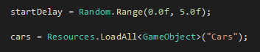

The spawners also spawn the cars based on the spawn frequency of each country’s number of cars per capita.
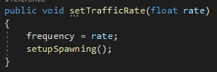

Despawners:
The despawners for the game are a collision entry where when the cars enter a box the car gets destroyed, this is used so that there aren’t lots of cars all spawned in at once lagging the game out. To hide the spawner and despawners boxes tunnels were made to make it look like the cars were exiting and entering a tunnel instead of just appearing and disappearing.
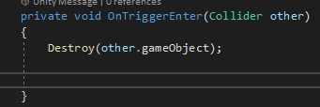
Gaining Points
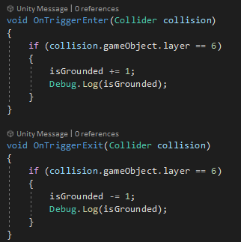
The points in the game are gained only when the player is on the road trying to dodge cars. The way the points work is by attaching an invisible cube to the player's feet and when the cube comes into contact with the layer that the road is set to the player starts to gain points and when the cube exits the layer the player stops to gain points.

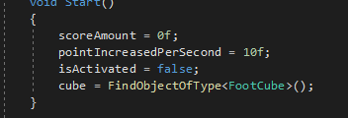
the points are increased in intervals of 10 per second when the player is on the road. Points can be used in the shop to buy power-ups.

Checkpoints:
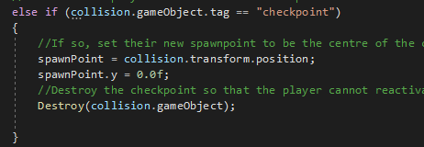
The game has a set checkpoint after passing through all the lanes of a country, the checkpoints are where the player can get a spawn point so that if they die, they will not have to go back at the start of the game.
The checkpoints work by having an invisible area in the middle of the that when the player walks through it will activate the checkpoint.

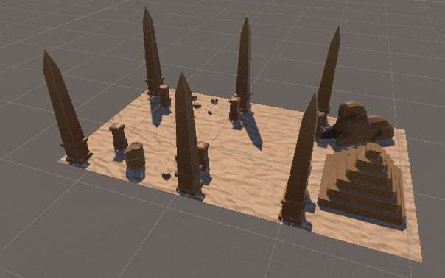
On each checkpoint the is an area of open space on the left-hand side where there is a random chance that the shop can spawn, and the player can use their points to buy powerups. Each country's checkpoints have iconic assets to the country to make it easier to identify them, some of the checkpoints also have main entry and exit to make it a bit more difficult for the player.

Evaluation

What went well?
There were many things that went well in the game such as getting the spawner and despawners to make and destroy the cars because that is one of the main components of the game and without it, there would be no difficulty to the game, another part of the game that went well was getting the player to only gain points when they were standing on the road this helped add to the difficulty because without points the player is not able to buy powerups in the shop to help them. Some of the things that went well as a team was getting the player to be able to grab an item from the shop and it go into their inventory and deduct the points from their total points, another feature that the team implemented well was the VR controllers with the player being able to use all fingers on each hand which allows the player to grab certain objects, the player also has full movement in the game and not just a teleporting system like some VR games.

What didn’t go well?
Some aspects of the game that did not go well were designing the checkpoints based on the country theme, this did not go very well because there was a lack of free assets to use and due to time constraints making assets for each country was not a good use of the team’s time. Some aspects of the game that we as a team did not do very well was that not enough focus was spent on how the game looked like as the majority of the focus was spent on getting the game's features to work.

What could be Improved?
Parts of the game that could be improved are, the assets on the checkpoints because some of the checkpoints are quite bare and don’t properly represent the country that they are supposed to be, another part of the game that could be improved is the number of lanes that each country has which makes the game overall longer and more difficult. Some of the things we as a group could have improved on were spending more time on improving the appearance of the game and prioritizing it over other smaller features in the game. Another thing that could have been improved on was adding a boundary to the game as none of the checkpoints have walls around them.

Wider game project
The game features implemented would affect the main game project due to them being key game features that are used such as the car spawning and despawning because without that the game would have no difficulty or purpose to it.

Conclusion
In conclusion, there are many ways that data visualization can be used in the gaming industry whether it is simple visualization such as a health bar or more complex ones such as a detailed skill tree. As a team, we have implemented a few different types of data visualization such as a shop where you can see how many points you have and pick up power-ups which can be used to help the player, another visualization that we implemented in an inventory system where the player can see the power-ups that they have bought. All these different types of data visualization help bring the game together and let the user process lots of data with ease.

References
Hazzard, E. (2015, 02 03). February 03, 2015 · 13 min read. Retrieved from game analytics: https://gameanalytics.com/blog/data-visualization-games/
Hedges Company. (n.d.). HOW MANY CARS ARE THERE IN THE WORLD IN 2023. Retrieved from Hedges Company: https://hedgescompany.com/blog/2021/06/how-many-cars-are-there-in-the-world/
Hipster Whale. (2014-2020). Crossy Road. Retrieved from Crossy Road: https://www.crossyroad.com/
tableau. (n.d.). Data visualisation beginner's guide: a definition, examples and learning resources. Retrieved from Tableau: https://www.tableau.com/en-gb/learn/articles/data-visualization#:~:text=Data%20visualisation%20is%20the%20graphical,outliers%20and%20patterns%20in%20data.
Titov, A. (n.d.). why is the unity game engine considered the best? pros and cons. Retrieved from stepico: https://stepico.com/blog/why-is-unity-the-best-game-engine-pros-and-cons/
unity. (n.d.). unity. Retrieved from unity: https://unity.com/
Zammitto, V. (2008). Visualization techniques in video games. london conference.

